
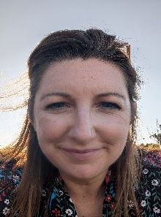
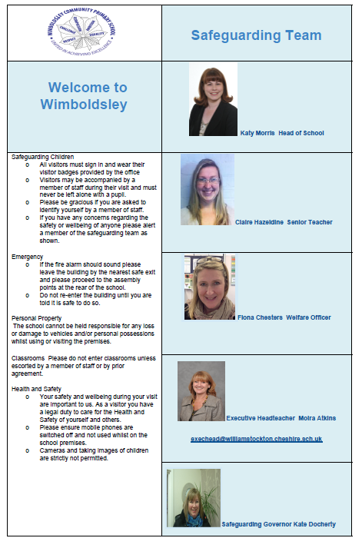
Phil Betley
Safeguarding Governor
Fiona Chesters
Student Welfare
Claire Hazeldine
Lead Teacher
Sarah Macaskill Headteacher

